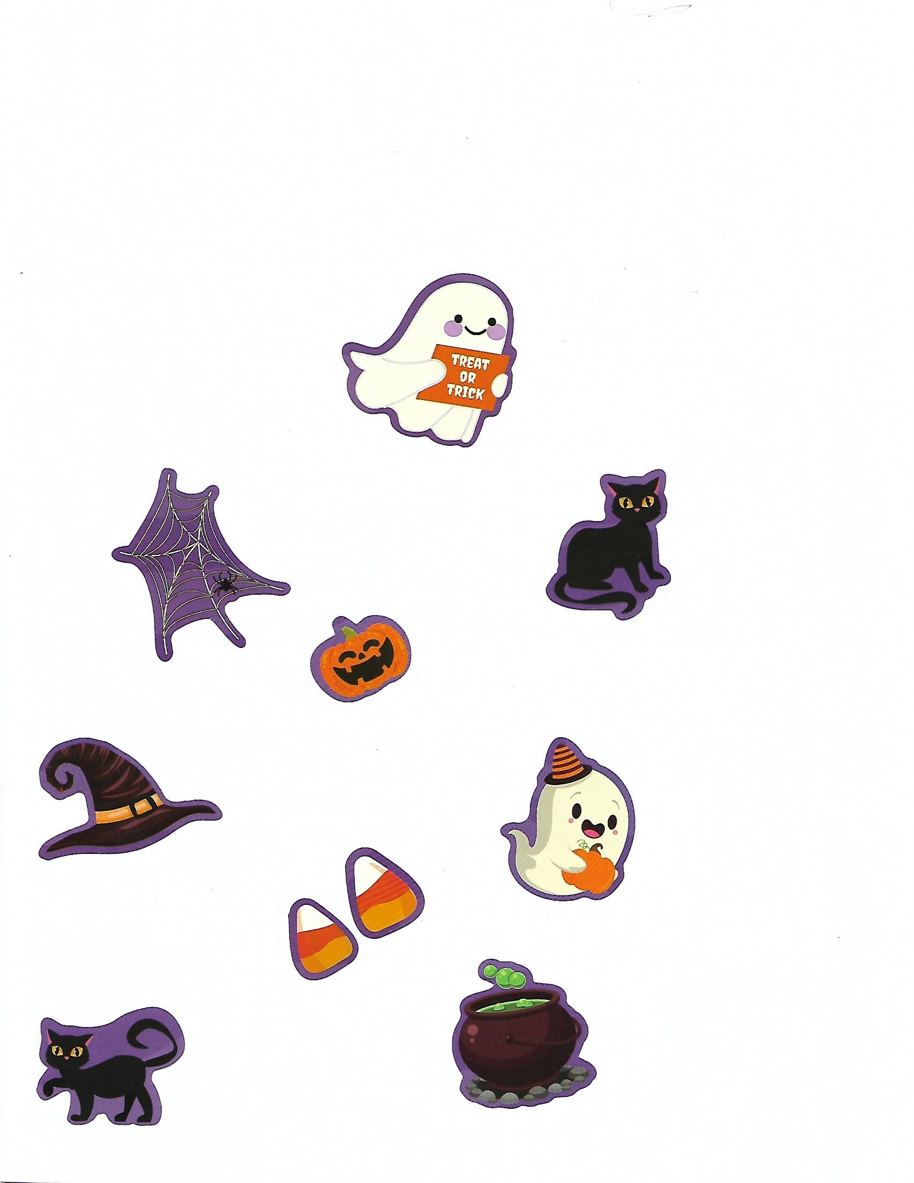 BOO!!!
YOU ARE INVITED TO THE FIRST AAUW
“HALLOWEEN MONSTER MASH
STAY AT HOME BALL”

NO COSTUME OR CANDY TO BUY!!
NO WITCHES OR GHOSTS TO AVOID!!
NO TRICKS! NO TREATS!

STAY COMFORTABLY AT HOME
AND HELP FUND STUDENT GRANTS WITH A DONATION!
(GUESTS WELCOME TO DONATE AND NOT ATTEND TOO.)
CHOOSE A DONATION LEVEL BELOW.
By November 9th mail checks payable to:
AAUW Glendale: Memo Section Student Grants
AAUW GLENDALE BRANCH
P.O. Box 887, Glendale, CA 91209-0887; 831-607-9303
PUMPKIN GHOST SPIDER
$1000_____ $750_____ $500_____

BLACK CAT CANDY CORN
$250 _____ $100 _____

OTHER: DESIGN YOUR OWN CAULDRON AMOUNT!
$______


